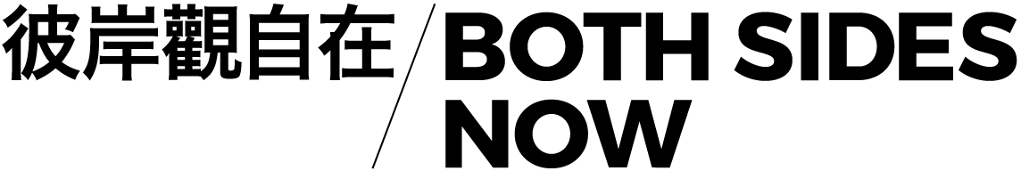

BOTH SIDES NOW 7: DeNatured – curated by videoclub (UK) & Videotage (HK)

“There is no longer a respective position - the real disappearing to make room for an image, more real than the real, and conversely - the remainder disappearing from the assigned location to resurface inside out, in what it was the remainder of, etc.” - Baudrillard, Simulacra and Simulation

“Metaverse” has become the new global buzzword. Derived from the science-fiction novel, Snow Crash (1992), the term represented a dystopian vision of the 21st century, where the global economy and political and governmental systems have suffered a violent breakdown. A place where physical reality and virtual space have converged, where people escape from the deconstructed real-world space.

While current technology has yet to deliver a seamless and persistent experience between reality and the virtual, the predicted 21st century - as imagined in the novel - is not far from what we experience here and now. War, economic downturn, the pandemic, collapsing trust in governments and extreme natural disasters have created unparalleled uncertainty on a global scale. Making speculative fictions appear ever more predictively realistic. Speculatively, one may wonder, how do shared environments, no matter built, virtual or in-between, offer us insight concerning our increasingly sci-fi-like lives?

In Hong Kong, the future has for some time been coexisting with the present in cultural representations. Ridley Scott portrayed “Hong Kong on a very bad day” in his 1982 science-fiction film, Blade Runner, where gigantic neon billboards in an overdeveloped urban environment became the most iconic imagery of the city. Ghost in the Shell, both the original anime, produced by Oshii Mamoru in 1995, and the science-fiction action film, directed by Rupert Sanders in 2017, used Hong Kong as a backdrop. In an environment where everything is in excess, yet disappears almost as quickly as formed, Hong Kong is like a real-life embodiment of the futuristic mise-en-scène portrayed in these films.

As these films conceive the hyperreal cityscape as a metaphor for a life in which a sense of self and the environment are perpetually mediated, they rightly point out an important question; How much artificial sensual enhancement and virtual replacement of reality can a person experience and still be considered real? Perhaps there is no answer to this question, and maybe we are still very far away from having one.

Yet, it is certain that Hong Kong’s people have become more and more integrated with computers and virtual environments. For example, amid the tightening social distancing measures, lunar new year flower markets this year have been replaced by metaverse marts, which consist of a few virtual pavilions, shops and an NFT gallery. Around the same time, a property tycoon from Hong Kong bought one of the biggest plots in The Sandbox, aiming to build an innovation hub that mimics the startup frenzy. Digital art fairs selling NFTs have become a must-go destination for city hipsters. Apart from the commercial sector, one of the most historic brick-and-mortar theme parks owned by the government, Ocean Park, is planning to create digital entertainment experiences through NFTs and The Sandbox.

Perhaps Hong Kong’s cityscape provides a perfect setting for “tech-noir” like what we see in Snow Crash. If this is the case, will future simulated environments offer us freedom in reimagining what is lacking in the real world? Is our non-physical existence in the virtual world entitled to rights, freedom, and responsibilities that take place in reality? What if the virtual environment is merely a mirror of the prevailing corporatocracy?

Microsoft describes the metaverse as the next evolution of the internet. Mark Zuckerberg has restyled Facebook as Meta, firmly nailing his colours to the mast. These two giants offer little in terms of developing a new version of the internet that is not led by an evolved capitalism. And what does a new internet, one reliant on growing demands on consumption and power, offer to a world which is suffering the impact of climate change and crisis? In Dec 2021, Intel suggested a working metaverse would require 1000x the power of today’s computing requirements to run effectively. How can the proposed metaverse represent this crisis and offer solutions, while gorging on energy?

One of the earliest representations of climate change’s impact in a metaverse-like world was on Second Life. In 2007, Japan, Netherlands and Ibiza were flooded in the virtual world, representing the impact of climate change. In 2018, the scientist-led Climate Fortnite Squad was established (and disbanded), offering opportunities to game and discuss climate change.

Through Both Sides Now 7’s latest programme, we explore how artists are disrupting, commenting upon, and engaging with virtual worlds, environmentalism and the coming metaverse.

Both Sides Now: DeNatured is the seventh edition of a long-term project that proposes re-readings of artists' moving image from China, the UK and beyond. In this new edition, videoclub (UK) and Videotage (HK) bring together international artists from the fields of film & video between April and June 2022. It explores how artists are interpreting different forms of environment, from real to virtual to spaces in between. It attempts to reconsider the evolving notion of environments and (meta)universes, via recent work by artists and filmmakers.

Text by Dr Isaac Leung and Jamie Wyld (co-curators of Both Sides Now)

