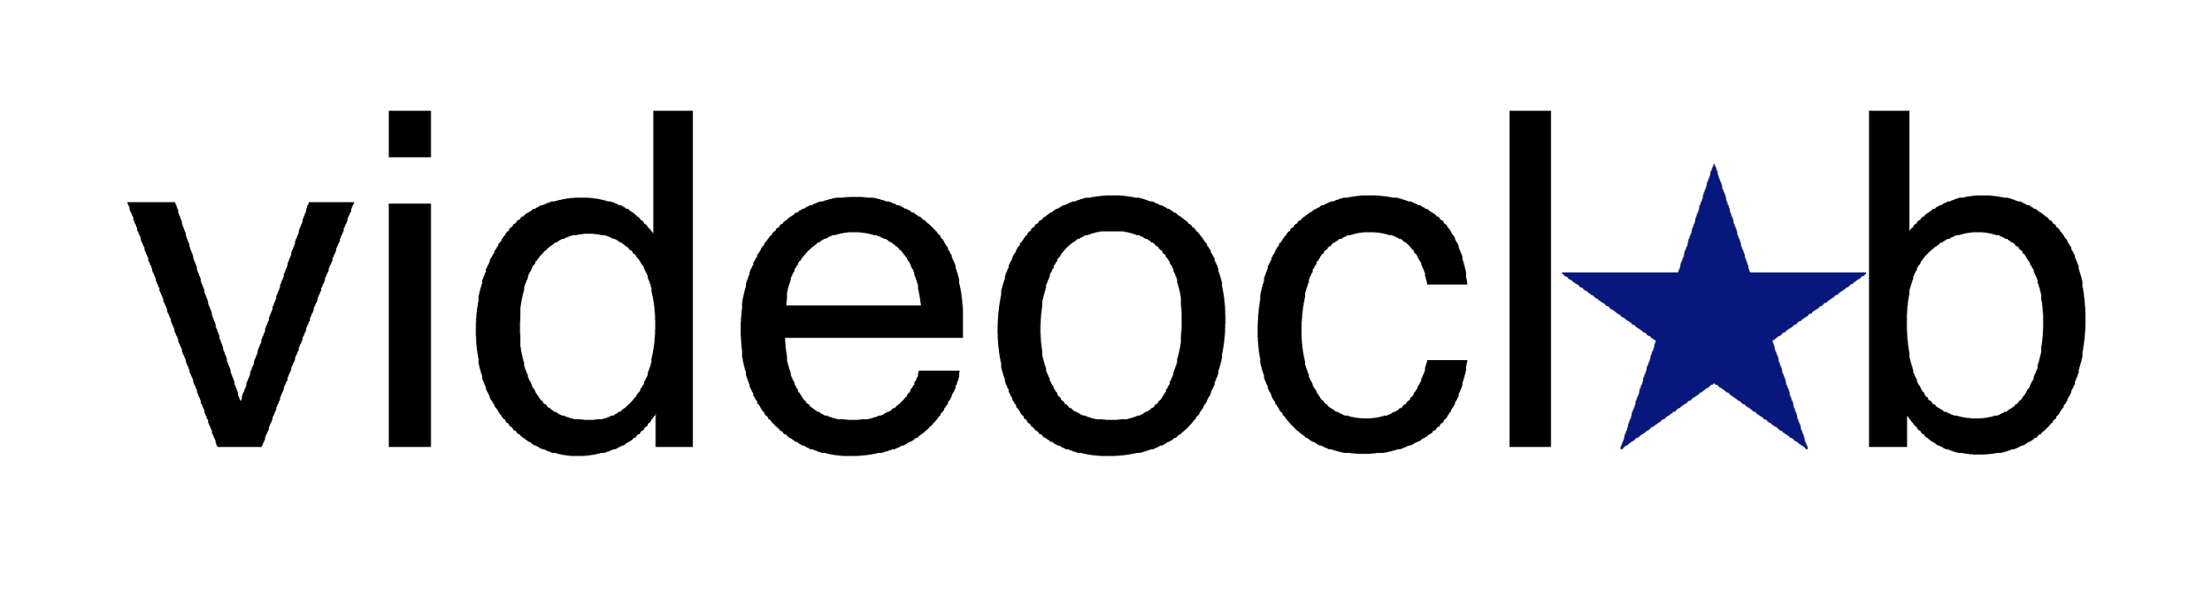

SELECTED 12

Selected 12 is a new collection of eight artists’ films touring the UK in 2022, taking place at some of the UK’s leading venues for showcasing artists’ film and video.

Shortlisted artists for the 2021 Film London Jarman Award – Adham Faramawy and Guy Oliver, FLAMIN and videoclub have selected some of the most outstanding work from early career moving image artists working in the UK.

Selected has been produced in partnership by videoclub and Film London Artists’ Moving Image Network (FLAMIN).

PROGRAMME

A leak, a draft, a mold, a flame – Laura Lulika, 2022, 9 mins
a leak, a draft, a mold, a flame, is anxiety-insomnia induced late night wonderings in the phone notepad. It's a fear of the unstable, a love for connection and disgust for the landlord. It's the shame and celebration of waste and being wasteful. It's speculative imaginings of a world in the pipes and gutters beyond the skin-brick, of where that could take us. Using a record of clogs and blockages from Lulika's own home and neighbourhood, in combination with recent personal experiences of being sick and housebound, a leak, a draft, a mold, a flame, wants to connect with your own creatures of the bog.

Womb – Sarah Gonnet, 2018, 2:17 mins
​Womb is a poetic autobiographical film about​drawing artistic inspiration from the practice of hoarding and collecting. Sarah is a hoarder of books, films and art. Her collection helps her to feel safe in a world where she has been repeatedly sexually assaulted. ​This escapism into other worlds has formed a hoard that inspires Sarah to create her own art, films, and writings.

small wet mouth – Ker Wallwork, 2019, 12 mins
small wet mouth is a 12-minute moving image piece exploring experiences of porousness, dissatisfaction and miscommunication. The visual material is a playful exploration of materials that can cross the thresholds of bodies (ours and animal) and cause lasting changes in broad ecosystems, and internal functions (particularly endocrine/hormonal functions).
The audio narrates the routine and unexpected activities of Nadia, Doug, and Whatshername as their paths cross at a fishing pond, where the effects of environmental chemicals are witnessed, and perhaps utilised.
Commissioned by Cicely Farrer, LifeSpace Gallery for the exhibition 'Disentangle: Science in a Gendered World' 2019

Hyperacusis (Part 1) – Sophie Hoyle, 2021, 7 mins
Hyperacusis (Part 1) is a personal exploration of scientific constructs and narratives around migration, race and the categorisation of social groups. Through experiments by the artist at the biohacking lab UrsuLAB in Bourges, they explore the intergenerational impacts of racism, colonialism, ableism and other socioeconomic inequalities. Made as part of an EMAP/EMARE residency at Antre Peaux, Bourges.

CONTENT WARNING: Contains footage of a scalpel incision into skin, a wound and blood being handled in a lab setting.

Honeysuckle Joyride – Jennifer Mehigan, 2021, 12:37 mins
Honeysuckle Joyride is a commissioned video essay in response to Bassam Al-Sabah’s show I AM ERROR at Gasworks, which opened in Summer 2021. The essay considers themes of decay, inter-species kinship and the Irish landscape through a post-humanist lens. Footage of various locations around the island is layered with computer-generated imagery, uncovering personal or domestic materialities of queerness, grief and horror as they intersect with the screen, and ideas of truth and reality in a space where public and private spheres are constantly colliding with and abstracting each other.

[sound of subtitles] – Seo Hye Lee, 2021, 1:37 mins
[sound of subtitles] is purposefully silent, allowing the audience to travel through the transition of videos and texts to conjure their own interpretation of sounds and events. By juxtaposing abstract, action and music-based subtitles, I aim to highlight how powerful the use of imagery and words can be and how much this can alter our perception of events. Regardless of hearing ability, one can explore their own unique soundscape and reimagine the meaning of listening.

Icarus – Jessy Jetpacks, 2020, 3:57 mins
Icarus is the second track from a six track concept album called ‘Day of the Challenger’. Originally composed and shown as part of an immersive synchronised audiovisual and virtual reality installation, this circular film was projected into a circular shadow. An eclipse. The album loops at sunrise, the passage of the sun over a barren desert is a motif echoed in the virtual reality space.
Within the virtual reality of the original installation the viewer is granted a growing flesh body that disintegrates into a stellar nursery. In this video the singing character appears as three avatars traversing a barren desert, made partly of flesh. At one point a fourth wall is introduced and broken as the artist scribbles clumsily on the screen.
The visual signifiers tell a story of transcending the self and depersonalising narrative, but the song lyrics speak of the price of ambition. The original story of Icarus is that he escaped his city prison on homemade wings. Then in his joy he perished by flying too high as the wax holding the wings melted under an unforgiving sun. These days you don’t even need to fly to get burned.
Adhering to the norms of your place, knowing what you should and shouldn’t do. It is difficult but its not problematic. The defence sequence is automatic.

TR333 – April Lin 林森, 2021, 10 mins
In collaboration with ecologist Dr. Nalini Nadkarni, artist-filmmaker April Lin 林森 presents TR333, a speculative documentary which imagines a new species of tree based on scientific literature on plants and climate hardiness. Their hybrid forms and body parts are a patchwork, an amalgamation of different tree types, this tree is a climate adaptive response, a lifeform born out of resilience and hope. As the spirit inhabiting the tree emerges to converse with the viewer, they share with us their experiences of ecocidal generational trauma, urging us to reflect around the ways all the beings on the planet are deeply interlinked, and to honour our collective responsibility towards one another. Using a blend of 3D animation, found footage, and a musical score based on data sonification, TR333 uses the speculative to recast the ecological crisis, asking ‘Why is this important?’ from a multispecies and affective gaze.
Commissioned by Sheffield DocFest and supported by Wellcome.

Selected 12 is produced by videoclub and Film London Artists’ Moving Image Network, and is supported by Arts Council England and Film London.

Thanks to: CCA Glasgow, Fabrica, Royal College of Art, Nottingham Contemporary, G39 and John Hansard Gallery.

See videoclub’s other work and join our mailing list: www.videoclub.org.uk and follow us on Instagram and Twitter @videoclub_uk

